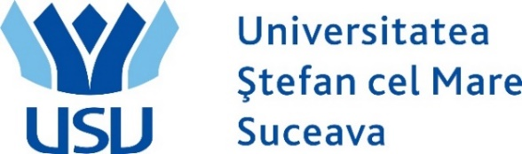

SEC2U 2017 in USV

SEC2U Event hosted by Stefan cel Mare University of Suceava

Date: 26th of October, 2017
Timetable: 10:00 – 19:00
Place: Stefan cel Mare University of Suceava, Building E, Conference Hall

SCHEDULE
- 09:00 – 09:30 Registration of Participants
- 09:30 - 10:00 Opening Session (welcoming participants and guests). Startup Europe University Network presentation
- 10:00 - 12:00 Building Entrepreneurial Eco-systems – trends and opportunities
- 12:00 - 12:30 COSME Erasmus for Young Entrepreneurs in Romania – Stefan cel Mare University Bringing New and Host Entrepreneurs Together
- 12:30 - 14:00 Lunch Break

- 14:00 – 15:00 INCUBAF – USV Business Incubator: The Perfect Place for Student Entrepreneurs
- 15:00 – 15:30 Regional Entrepreneurial Initiatives and Financing Opportunities – Romania Startup+
- 15:30 – 16:00 Challenges and Obstacles for Wannabe Entrepreneurs – analysis and solutions
- 16:00 – 16:30 Cast - Entrepreneurial Student Club – Stairway to Success
- 16:30 – 17:00 Business Café – Sharing Success Stories
- 17:00 – 19:00 USV - Entrepreneurial University – Entrepreneurial Students
- 19:00 Closing of the Event

